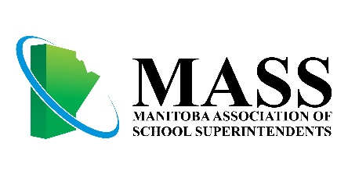

**MASS Executive Director Announces His Retirement**



After five years as Executive Director of the Manitoba Association of School Superintendents, Ken Klassen has announced he will be retiring effective July 31, 2018.

Klassen made his official announcement at the December 8th MASS Board Meeting. President Donna Davidson offered her thanks on behalf of the board for the exemplary service provided by Mr. Klassen to the organization, as well as congratulations and best wishes on his pending retirement. The Board of Directors will begin the process of recruiting a replacement immediately.