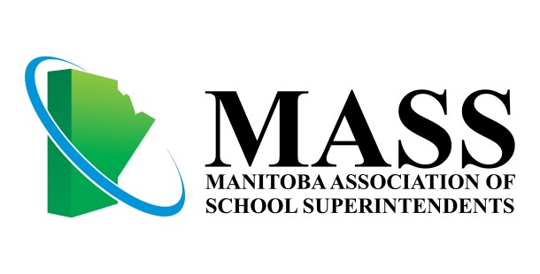
PRIORITIES 2018 - 2019

Mission:
MASS provides leadership for public education by advocating in the best interests of learners, and supports its members through professional services.

MASS believes that our mandate is to be leaders of learning, in our local school systems and in the broader domains of provincial, national and global public education. MASS believes a quality education empowers the whole child to constructively participate in global society.

We model learning that is:
- active and visible;
- based on robust research;
- tested through purposeful application in the field;
- evaluated using a wide range of meaningful data.

We take responsibility for our own continuous learning and the learning of everyone we lead:
- creating and fostering safe, supportive, inclusive and challenging environments;
- ensuring essential learning for each and every child;
- preparing others to go beyond our own learning.

We are guided by our learning in shaping policy and practice to achieve what is best for the children in
our care.
MASS believes that improved achievement and well-being for all of our students requires a shared commitment to raising both equity and quality.
- A conscious and persistent commitment to equity, system-wide and across sectors, leads to poverty reduction, greater inclusion and an appreciation for the riches that diversity brings.

- A purposeful and sustained commitment to quality education for every student increases the capacity for teaching, learning and leading throughout the system.
- A strong grounding in literacy and numeracy and a rich learning experience involving inquiry, curiosity, creativity and artistic expression enables all students to achieve success and to flourish in life, academics and career.

- A respect for and openness to authentic youth voices and support for meaningful student action are critical for building capacity and self-efficacy in our students.

MASS actively works towards equity and quality throughout the public education system, with a special focus on three action areas:  Early Learning  Indigenous Education Mental Health and Well-Being | 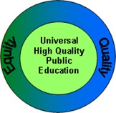
The Early Learning Committee will take leadership to ensure that MASS:
- Advocates for full implementation of the Calls to Action in the MASS position paper on Early Childhood Education.
- Participates actively on the Provincial Educaring Committee.
The Indigenous Education Committee will take leadership to ensure that MASS:
- Builds capacity in MASS and school divisions to address the Truth and Reconciliation Calls to Action.
- Promotes ever increasing academic achievement, graduation, school completion and positive life outcomes for Indigenous students, informed by collective inquiry into evidence
- Actively supports the teaching of Indigenous perspectives, corrective history and culture and the use of Indigenous languages.
The Mental Health and Well-Being Committee will take leadership to ensure that MASS:
- Advocates for an implementation of a comprehensive provincial Children and Youth Mental Health Strategy.
- Collaborates with The Education for Sustainable Well-Being Research Group at the University of Manitoba and Manitoba Education and Training to develop tools and indicators for assessing the well-being and well-becoming of students in schools.
- Pursues inter-sectoral liaisons with public and mental health organizations and agencies.
- Contributes to a national voice on mental health through CASSA and through input into the Canadian Mental Health Strategy.
- Promotes Mental Health Literacy in mental health for all educators and pre-service educators.
- Renewing MASS Mental Health position paper and calls to action.

