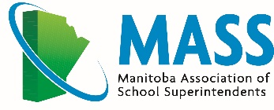

Leadership Development Workshop

“The Road to Reconciliation”

Thursday, January 12th and Friday, January 13th, 2023
Hilton Garden Inn, 495 Sterling Lyon Parkway, Winnipeg MB

(Click here for MASS online room reservations)

Facilitators: MASS Leadership Development Committee
Guest Speakers: Andrew Stobo Sniderman and Douglas Sanderson

Workshop Description
January 12 During the evening session, various school divisions will present experiences related to the topic. There will be an opportunity for dialogue.

January 13 During their morning keynote, authors Andrew Stobo Sniderman and Douglas Sanderson will discuss lessons from their acclaimed book, Valley of the Birdtail: An Indian Reserve, a White Town, and the Road to Reconciliation, which describes how two communities (and their schools) become separate and unequal, and what it means for the rest of us.

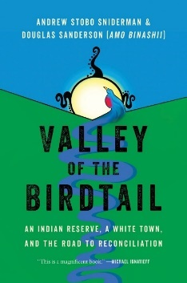
Divided by a beautiful valley, the town of Rossburn and the Waywayseecappo Indian reserve in Manitoba have been neighbours nearly as long as Canada has been a country. Their story reflects much of what has gone wrong in relations between Indigenous Peoples and non-Indigenous Canadians. It also offers, in the end, an uncommon measure of hope.

During the afternoon session, the authors will moderate a discussion on potential next steps for educational leaders working toward reconciliation.

Schedule
Thursday, January 12 Friday, January 13
9:00 am - 12:00 pm Session
5:30 pm - 7:00 pm Dinner 12:00 pm - 1:00 pm Lunch
7:00 pm - 9:30 pm Session/Networking 1:00 pm - 2:30 pm Wrap-up

Registration: $250.00 (Includes Thursday dinner and Friday lunch)

