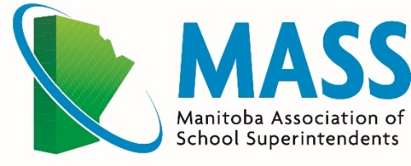
.
2023 ANNUAL GENERAL MEETING
The Leaf, Assiniboine Park

Thursday, May 18, 2023

Agenda

9:00 a.m. Welcome and Land Acknowledgement
Assiniboine Park is located on Treaty 1 territory within the Province of Manitoba, the traditional lands of the Anishinaabe, Cree, Oji-Cree, Dene, and Dakota Peoples, and the national homeland of the Red River Métis.
We respect the treaties made on this land and acknowledge the harms and mistakes of the past and present. We dedicate ourselves to authentic alliances with Indigenous communities in a spirit of reconciliation and cooperation.

9:15 a.m. Usha James, Executive Director at The Critical Thinking Consortium (TC²)

10:20 a.m. Nutrition Break and Networking

10:35 a.m. Future Direction for Indigenous Education Committee Lorie Henderson
Executive Members Travel Compensation Proposal Stephen Ross
Committee re Overlap for 2023-2024
Funding Review
Other Committee Updates

11:30 a.m. Assiniboine Park Conservancy Overview & Further Directions in Education
Trevor Clearwater, VP, Guest Services
Jody Watson, Senior Director of Programming and Education
12:00 p.m. Lunch

1:15 p.m. Annual Business Meeting
    - Annual Reports
    - Elections
    - 2023 – 2024 Priorities: Round Table Discussions
    - Resolutions
    - New Business

3:30 p.m. Tour of The Leaf

Recognition Banquet

4:30 pm Reception (Cash Bar) Mezzanine, 2nd Floor
5:45 pm Seating for Dinner Banquet Rm, 2nd Floor
6:00 pm Dinner

During and following dinner, we will be honouring the contributions of members retiring this year
and recognizing members celebrating a service anniversary.

