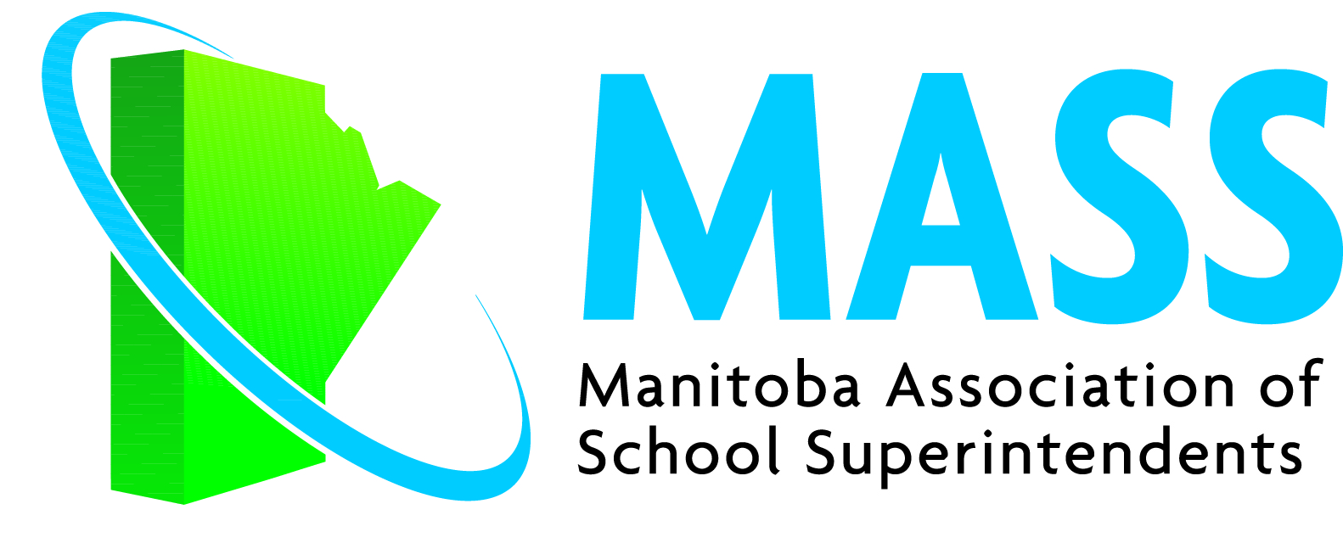

Summer Institute Program
August 16 – 18, 2023
Elkhorn Conference Centre

USHA JAMES

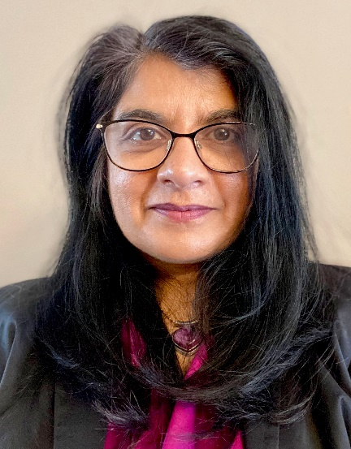
Leading in a Good Way

Keynote
Leading in a Good Way: How might we meaningfully use data as guidance?

Interactive Sessions

Making Sense of the Numbers: Thoughtfully engaging with big data
Beyond Parent “Involvement”: Strengthening support for students by developing truly collaborative partnerships with families and communities
Beyond Student “Voice”: Meaningfully centring the student experience in decision making in all classrooms, schools and systems.

► Tuesday, August 15 Pre-Sessions for Executive and New Members Only
10:30 a.m. – 4:00 p.m. Executive Planning Session Salon A
12:00 p.m. – 1:00 p.m. Lunch for Executive and New Members
1:00 p.m. – 4:00 p.m. New Members Orientation Session Ten Restaurant
6:00 p.m. Reception and Dinner for Executive and New Members Salon D

► Wednesday, August 16

9:00 a.m. – 10:30 a.m. New Members Breakfast Private Dining Room
11:00 a.m. Golf Tournament Poplar Ridge Golf Course
6:00 p.m. – 6:45 p.m. Networking Happy Hour Cash Bar Salon ABC
6:45 p.m. Dinner and Summer Institute Commencement Salon ABC
8:15 p.m. – 9:15 p.m. Keynote – Usha James

Leading in a Good Way: How might we meaningfully use data as guidance?
The demands on teachers, principals and senior administrators to engage with data are significant and are often seen as unwelcome accountability measures causing resistance or mere compliance. However, by redefining data as guidance, we can adopt a powerful approach that encourages every member to actively seek, gather, and comprehend data, empowering them to feel confident and competent in critically analyzing their own practices. In this keynote, we will consider how critical inquiry might support the development of the mindsets and competencies required to meaningfully use data to support all learners, especially those who need us to change our practices the most.

9:30 p.m. Hospitality Chalet 651 St. James School Division invites registrants and their guests
to come enjoy drinks (spirited and non-alcoholic options),
snacks and an opportunity to network!

► Thursday, August 17

7:30 a.m. – 8:45 a.m. Breakfast Buffet Ten Restaurant Included for registrants with name tags. Others may purchase breakfast on site.

8:45 a.m. – 10:15 a.m. Interactive Session One Salon ABC

Making sense of the numbers: Thoughtfully engaging with “big” data

Examining achievement data, perception data and demographic data in silos can lead to a proliferation of disconnected goals and contribute to a system that feels overwhelmed by multiple challenges. How might we thoughtfully analyze data and look for patterns that help us better see our students and ourselves? In this session we will think about how we might examine different data sets in relation to each other and understand that the analysis that emerges is a catalyst for further inquiry.

10:15 a.m. – 10:30 a.m. Break

10:30 a.m. – 12:15 p.m. Interactive Session Two
Beyond Parent “Involvement”: Strengthening support for students by developing truly collaborative partnerships with families and communities.

Often the students whom we are unsure how to support are the same students whose parents we have the least connection with. How might we better understand students' strengths and experiences by intentionally and systematically seeking guidance from their families? In this session, we will examine a variety of ways that data can be gathered from families and communities in ways that are respectful, authentic, meaningful and powerful in guiding our system, school and classroom decisions.

12:15 p.m. Lunch Ten Restaurant
Included for registrants with name tags; others may purchase lunch on site.

1:15 p.m. – 3:15 p.m. Interactive Session Three Salon ABC

Beyond Student “Voice”: Meaningfully centring the student experience in decision making in all classrooms, schools and systems.

What does it mean to meaningfully centre student experience? How might students provide crucial guidance for our planning? In this session, we will consider what we might affirm and refine about our current practices related to gathering and responding to student voice. We will examine potentially impactful practices for increasing student agency in creating more equitable, inclusive and supportive classrooms, schools and systems.

3:15 p.m. Get a Life! On-your-own
Activities at Elkhorn include golf, tennis, fishing,
beaches, hiking/biking trails, fitness centre and spa

Everyone Welcome!
► Thursday Evening Events Bring Guests and the Whole Family
(S(((

CASH BAR

5:30 p.m. Reception and Prizes Room behind Salon ABC
Golf prizes and other prizes for all registrants

6:30 p.m. Summer Institute BBQ
Included for registrants with name tags Room behind Salon ABC
extra for guests and family

► Friday Morning, August 18

7:30 a.m. – 8:45 a.m. Breakfast Buffet Ten Restaurant Included for registrants with name tags. Others may purchase breakfast on site

8:45 a.m. – 11:00 a.m. Closing Challenges
Leading in a Good Way: The place of data in robust critical inquiry approach to system, school and classroom improvement

In our closing session, we will consolidate our learning and examine how a critical inquiry approach is broadly supported and enhanced by reframing data as guidance. We will revisit our initial thinking about what it means to lead in a good way and ensure that you are ready with practical tools, actionable next steps.

11:00 a.m. Wrap-up

Usha James

Usha James spent 12 years as a secondary teacher and five years seconded to OISE at the University of Toronto, as an instructor in the Initial Teacher Education Program and Director of the Secondary Program. She has authored textbooks, teaching and learning resources, and curriculum documents with the aim of supporting educators and leaders seeking to refine their practice. Usha has contributed to The Critical Thinking Consortium (TC²) for many years as a resource writer, editor, speaker and facilitator of professional learning. She was appointed Executive Director of TC² in 2016. Usha has worked with educators and administrators of kindergarten to post-secondary students, supporting their efforts to improve the quality of their students’ thinking. She has seen how an understanding of how to nurture quality thinking can deepen educator understanding and practice of assessment, instruction, curriculum design, literacy, numeracy, differentiation and equity. Usha has worked extensively with senior district leaders to help them nurture thinking schools and systems, supporting their strategic planning and building capacity in leadership teams to think critically about their practice.

Organized by the MASS Professional Learning Committee 2022-2023
Carolyn Cory (Chair), Leanne Peters, Matt Henderson, Karen Boyd, Darlene Willetts, Jon Zilkey and Cheryl Mangin, with assistance from Barb Isaak, MASS Executive Director

-
MASS OFFICE

Phone: 204-487-7972
Fax: 204-487-7974
Website: www.mass.mb.ca

Executive Director:
ken.klassen@7oaks.org

2018 Conference & PD Events
2024 Conference and PD Events

MASS Fall Members Meet
October 27/23, Legacy Centre

MASS Leadership Development Module I
January 11-12, Hilton Garden Inn

MASS Spring Members Meet
March 1, Legacy Centre

MASS Leadership Development Module II
April 18 – 19, Hilton Garden Inn

MASS Annual General Meeting & Recognition Banquet
May 16, The Leaf

MASS Summer Institute
August 13, Executive & New Members Pre-Sessions
August 14-16, Lakeview Hecla Resort

MASS Fall Members Meet
October 4, Legacy Centre

Visit the MASS website for more
information on the above sessions.

MASS OFFICE

Executive Director:
Barb.isaak@mass.mb.ca

Executive Assistant:
karen.wohlgemuth@mass.mb.ca

Barb Isaak: 204-794-8537
Karen W: 204-871-3466
Website: www.mass.mb.ca

Mark Your Calendars!

