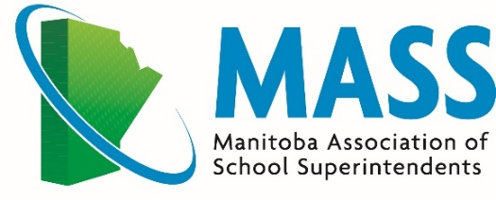

FALL MEMBERS MEET
October 25, 2024
St. Vital Room, Louis Riel School Division
900 St. Mary’s Road, Winnipeg

AGENDA

8:40 Smudge (Optional – front solariaum) Marsha Missyabit

9:00 – 9:10 Welcome and Land Acknowledgement Leanne Peters

9:10 – 9:45 Presentation of 2023-24 Year-End Financial Statements Ryan Rawluk
- Motion to approve Auditor’s Report Dan Ward
- Motion to retain Rawluk & Robert as Auditors for 2024-25

Pinning of New Members Jason Young/Jenness Moffatt

Proposal to amend criteria for Associate Members Jason Young

9:45 – 10:15 Strategic Planning Usha James

10:15 – 10:30 Nutrition Break

10:30 – 11:30 Committee Meetings / Conversations

11:30 – 12:00 Deputy Minister of Education, Early Childhood Learning Mr. Brian O’Leary
12:00 – 1:00 Lunch

1:00 – 3:00 Paul Grower and Kelsey Yakimoski, of Fillmore Riley LLP, will provide a refresher and update on The Freedom of Information and Protection of Privacy Act (“FIPPA”). The presentation will focus on practical tips to assist Divisions in dealing with FIPPA.
3:00 – 3:15 Closing Remarks

