

**Summer Institute Program**

**August 13 – 15, 2025**

Elkhorn Conference Centre

**Dr. Steven Katz**

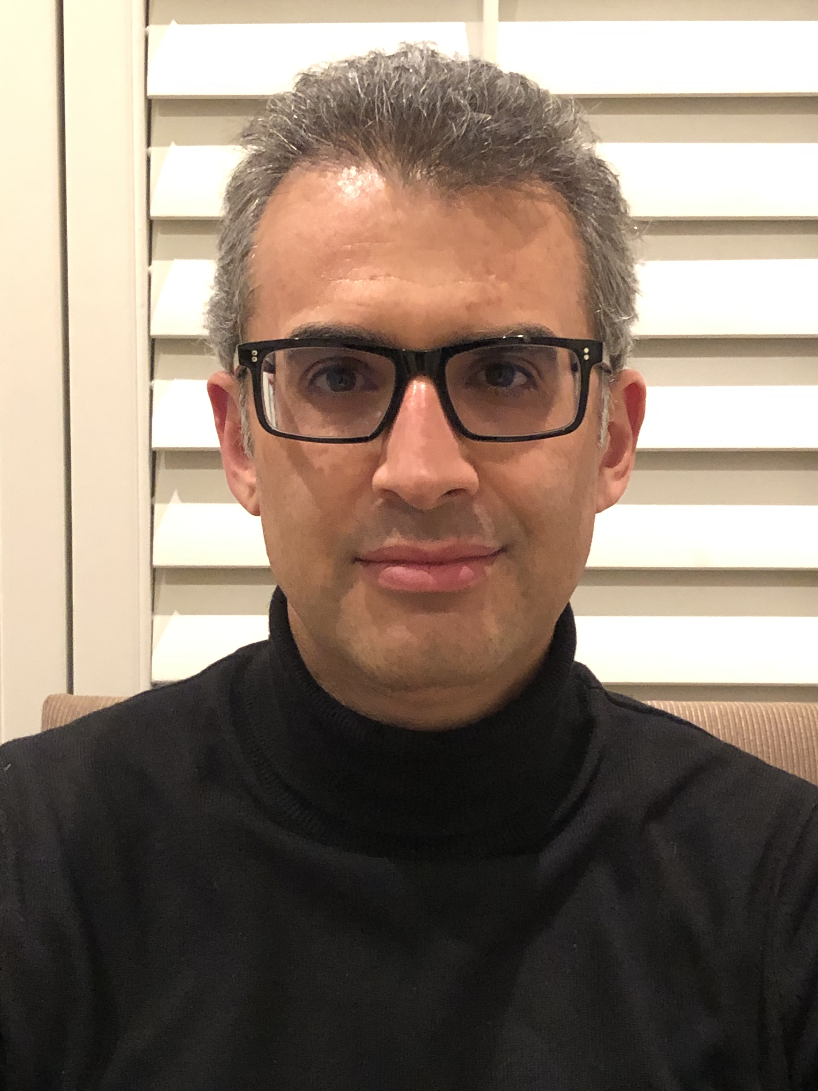

**LEADERSHIP IN COMPLEX (AND DIVIDED) TIMES**

**Keynote**

Proceeding Beyond Polarity: Leading Through Tension

**Interactive Sessions**

**Mirrors Before Windows: Leading for Quality Implementation**

Getting Better at Feedback: The Power of the Pull

**Change Agency: Leading System Change and Transformation**

**Re-culturing Leadership for Organizational Change**

**► Tuesday, August 12 Pre-Sessions for Executive and New Members Only**

10:30 a.m. – 4:00 p.m. Executive Planning Session *Salon A*

12:30 p.m. – 1:30 p.m. Lunch (Executive and New Members)  *Ten Restaurant*

1:30 p.m. – 4:00 p.m. New Members Orientation Session *Salon C*

6:00 p.m. Reception and Dinner for Executive & New Members *Salon D*

**► Wednesday, August 13**

9:00 a.m. – 10:30 a.m. New Members Breakfast *Ten Restaurant*

11:00 a.m. Golf Tournament  *Poplar Ridge Golf Course*

5:40 p.m. All members invited to participate in a smudge

to open the conference & new school year *Back yard of Chalet 651*

6:00 p.m. – 6:45 p.m.Networking Happy Hour *Cash Bar* *Salon ABC*

6:45 p.m. Dinner and Summer Institute Commencement*Salon ABC*

8:00 p.m. – 8:20 p.m. Opening Remarks

8:20 p.m. – 9:20 p.m. Keynote – Steven Katz

**Proceeding Beyond Polarity: Leading Through Tension**

Today’s educational leaders are navigating increasingly polarized environments, where debates over student discipline, equity, identity, and academic priorities often become entrenched and divisive. These tensions can fracture communities and undermine the core mission of serving students. This keynote explores how leaders can move beyond binary thinking and reactive decision-making by embracing complexity and fostering inclusive, principled leadership. Drawing on experiences from California and Ontario, I outline five key strategies—developing guiding principles, designing effective processes, adopting an open-to-learning stance, leaning into complexity, and building diverse coalitions—that help school systems respond thoughtfully to conflict and lead with integrity in challenging times.

9:30 p.m. Hospitality *Chalet 651*

***Lord Selkirk and Lakeshore School Divisions***

*invite registrants and their guests*

*to come enjoy drinks (spirited and non-alcoholic options), snacks*

*and an opportunity to network!*

**► Thursday, August 14**

7:30 a.m. – 8:45 a.m. Breakfast Buffet (*Conference registrants only)*  *Ten Restaurant*

8:15 a.m. Smudge (Optional)  *TBD*

8:45 a.m. – 10:15 a.m. Interactive Session One  *Salon ABC*

**Mirrors Before Windows: Leading for Quality Implementation**

In this session, we’ll explore why even the most well-researched, evidence-based practices often struggle to take hold in our schools. Together, we’ll examine what it really takes to move from knowing what’s supposed to work to actually making it work—through a process we call quality implementation.

We’ll look at how successful implementation depends not only on clear direction and system-wide expectations, but also on our ability to respond to the unique and complex realities of our local contexts. We’ll discuss the importance of balancing stability with agility, and how this balance can dramatically increase the likelihood of meaningful, lasting change.

Most importantly, we’ll reflect on the role we play as leaders in shaping the conditions for success. By learning to recognize and challenge our own assumptions and cognitive biases, we can lead with greater clarity, humility, and impact. This session invites us to look inward before we look outward—polishing the mirror before opening the window—so we can lead implementation efforts that are both grounded in evidence and responsive to the people and places we serve.

10:15 a.m. – 10:30 a.m. Break

10:30 a.m. – 12:15 p.m. Interactive Session Two  
  
**Getting Better at Feedback: The Power of the Pull**

Building on the previous session, we will highlight the essential role of “feedback” in learning and improving. While most system leaders think about feedback in terms of giving it, it turns out that sharpening one’s skillset in this domain is deeply connected to one’s ability to *receive* feedback well. It has been suggested that there is little that affects the learning culture of an organization more than the skill with which system leaders (like superintendents and assistant superintendents) *receive* feedback. In this session, we will learn what it means to receive feedback well and connect this expertise – in an intentional way – to creating an organizational culture of adaptive high performance.

12:15 p.m. Lunch*(Conference registrants only)* *Ten Restaurant*

1:00 p.m. – 3:00 p.m. Interactive Session Three *Salon ABC*

**Change Agency: Leading System Change and Transformation**

In this session, we’ll explore the complex and essential work of leading system-level change in education. Drawing from systems thinking, implementation science, and organizational change theory, we’ll examine how leaders can intentionally disrupt the status quo to foster meaningful, sustainable transformation.

Through the lens of continuous change, we’ll consider how to align organizational components such as strategy, structure, culture, and people, and how to lead within the tension between stability and adaptation. We’ll also explore the habits of systems thinkers, the importance of small wins, and the role of feedback and accountability in building momentum. This session will challenge us to reflect on our own experiences with change, the roles we play, and the paradoxes we must navigate as leaders.

3:00 p.m. – 3:45 p.m. **Strategic Planning and MASS Committees**

Over the past year, we have been working on implementing our strategic plan and progress has been made! Brief updates will be provided highlighting steps in our journey to date, and the organizational changes which have been introduced as a result of feedback from members.

3:45 p.m. **Get a Life!** *On-your-own*

*Activities at Elkhorn include golf, tennis, fishing,*

*beaches, hiking/biking trails, fitness centre and spa*

**► Thursday Evening Events**

5:30 p.m. Reception (**Cash Bar**)*Salon ABC*

5:45 p.m Golf Prizes

6:30 p.m. Summer Institute BBQ *Salon ABC*

*Included for registrants; extra for guests and family*

**► Friday Morning, August 15**

7:30 a.m. – 8:45 a.m. Breakfast Buffet (*Conference registrants only) Ten Restaurant*

8:15 a.m. Smudge (Optional) *TBD*

8:45 a.m. – 11:00 a.m. Closing Challenges

**Re-culturing Leadership for Organizational Change**

This session explores how leadership must evolve to meet the demands of meaningful, system-wide change. We’ll examine the central role of organizational culture in enabling or impeding progress, and why efforts to improve often falter not for lack of strategy, but because of unaddressed cultural dynamics. Drawing on systems thinking, cognitive psychology, and implementation science, we’ll consider how leaders can shift from isolated efforts to collective, networked learning that is contextually grounded.

We’ll look at the habits of systems thinkers and the power of lateral leadership in building trust, capacity, and shared accountability. Special attention will be given to understanding coherence as a foundational element in the system transformation process—how aligning vision, structures, relationships, and learning can create the conditions for sustainable change.

Through the lens of Networked Learning Teams, we’ll explore how we can lead school improvement in ways that are responsive, relational, and rooted in real-world complexity. This session invites us to reframe leadership not as a top-down directive, but as a collaborative, adaptive process of learning and change.

11:00 a.m. Wrap-up

**DR. STEVEN KATZ**

Dr. Steven Katz is a professor in Applied Psychology & Human Development at the Ontario Institute for Studies in Education (OISE) of the University of Toronto (UT), where he teaches in the Child Study and Education graduate program. He is the recipient of the OISE/UT-wide award for teaching excellence. In addition, he is the Director of the research, evaluation, and capacity-building firm, Aporia Consulting Ltd.

Dr. Katz has a Ph.D. in human development and applied psychology, with a specialization in applied cognitive science. His areas of expertise include cognition and learning, teacher education, networked learning communities, leading professional learning, evidence-informed decision-making for school improvement, and leadership for system change. He has received the Governor General’s medal for excellence in his field, and has been involved in research and evaluation, professional development, and consulting with a host of educational organizations around the world. He is an author of several best-selling books, including *Leading Schools in a Data-Rich World; Building and Connecting Learning Communities*; *Intentional Interruption; The Intelligent, Responsive Leader;* and *Quality Implementation.*

**Organized by the MASS Professional Learning Committee 2024-25**

Leanne Peters (Chair)**,** Darlene Willets, Jon Zilkey, Jenness Moffatt, Jordana Buckwald, with assistance from Barb Isaak, MASS Executive Director

**MASS OFFICE**

**Phone: 204-219-7059**

**Website: www.mass.mb.ca**

**Executive Director:**

**Barb.isaak@mass.mb.ca**

**Executive Assistant:**

**karen.wohlgemuth@mass.mb.ca**